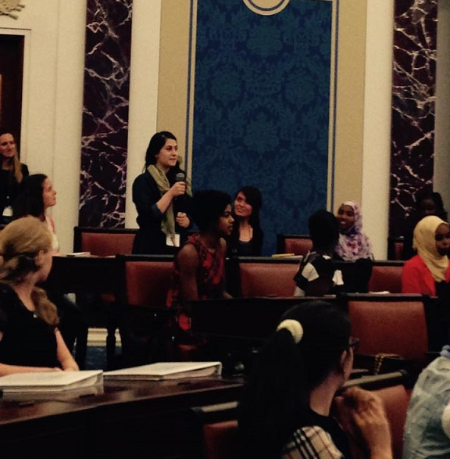AFGHAN Girls Leadership Program

Basira Daqiq

October 2015

Contents

Vision 3

Introduction 3

Statement of Problem 3

Structure: 4

Date: 4

Location: 4

Workshops: 4

Keynote Speakers: 5

Participants: 5

Schedule: 5

Community Services: 6

Trips: 6

Budget: 6

References 8

# Vision

I, as a person, who has the opportunity of role models, access to opportunities, and seeing the world in a more cosmopolitan way, feeling secure and safe... want every Afghan girl to have similar opportunities.

This summer I attended two leadership programs: Girls Leadership Worldwide and Women to Women, who are trying to empower peace and girls leadership around the world. Students gather from all around the world, and learned How to lead themselves and their people. Although both programs were for a short period of time, they had lifelong effects upon the students. Many students were surprised how profound these programs had been for them. I soon realized that Afghan girls can have the opportunities they need through such programs.

I believe that if we, Afghan women, do not care and create what we need for ourselves, no one else would. Thus I want to begin this process by a leadership program for Afghan young future leaders.

In this program they will talk to successful leaders, receive leadership training from professionals from around the world, and create useful connections with each other, trainers and speakers for networking to get to their goals. Therefore, please help us achieve this goal.

# Introduction

Afghanistan is a developing country, where devastation is a usual part of human’s life. Children need to work for their family as soon as they learn how to talk. The young generation is either struggling to fit in the education system, find job or get addicted to drugs.  Many families do not have a proper source of income. People are not sure if they will get back home alive once they stepped out of their houses. Simultaneously, it is known as one of the most dangerous places for a women to be. Girls get married as soon as they are able to hold a dish in their hand to cook for a man. Women lose their lives every day, because of lack of medical care and experiencing fundamental cultural violence. Afghanistan has the highest maternal mortality rate in the world. All of these features have resulted from the many years of war, dating back to 1979, which have degraded Afghan resources. Although, Currently Afghanistan is in a very hot phase of time. Foreign militaries, who have helped Afghan Army to defeat Taliban during the past decade, have left. This leaves Afghanistan with two possibilities: people of Afghanistan will become united, and stand for themselves, or they will be defeated by Taliban and the country will move back to 2001 situation.

# Statement of Problem

Afghan Women have to be empowered in order for Afghanistan to defeat its enemies. Nowadays, women are only expected to please other people to be accepted in the society. They always attend to the expectations and commands, and immediately respond to them. In many cases, they are those who save and carry on the cultural and fundamental ideologies whether consciously or unconsciously. They unconsciously keep them, because they think that it is accepted and expected in the society, thus it should be the right way of being treated. For example, women always feel responsible for all the house chores, child care and obeying men; because they think that it is the essence of being a good woman and wife. In the other hand, women consciously protect this believes because those who have the chance, never stand against of it and fight for the right way.

Although, many girls attend and successfully graduate from school in Kabul, most of them soon get married, and join the traditional chain of living. They have never had the chance to understand their purpose in life and set it as their priority, because of all the work they have to do for others. They do not have the opportunity of thinking about themselves, about what are their talent, passion and vision in life

In order for Afghan women to feel their real passion and responsibility by their own heart, they have to get exposed to the everything-possible world. Where they can get to know other women who have enormous accomplishments, and get inspired by them. There is not only a place needed, where they can find more opportunities in the area of their interest, but also where they will be encouraged by the people who are around them. Girls get married without resistance, because they do not know what else to do. If they get the chance to study overseas what they cannot study inside the country , to become leaders seeing other women leaders from inside and outside of the country, to create connection with those who are doing similar things with them and can help them accomplish their goals, this way they will not only empower themselves but also the country.

The Afghan Girls Leadership Workshop is an attempt to give Afghan girls a chance to explore themselves and discover their potential. In a war zone country like Afghanistan, we know many people, and especially girls, do not have the opportunity of realizing their individual and collective powers. By holding this workshop, we hope to inspire Afghan young women leaders to discover their purpose in life, start working on achieving it, and to use this sense of purpose to give back to their community.

## Structure:

The workshop will be held for 6 days from 8:30 AM to 4 PM, with 15 ethnically diverse participants from Afghanistan for the first time in 2016, and hopefully annually after that.

## Date:

Summer, 2016 will be the opening of the workshop. The exact Date will be set once the Afghan Calendar for the New Year is out, because we want to make sure that the date of the program will not conflict with the participants’ school schedule.

## Location:

Schools and institutes with adequate facilities, which be able to rent a conference place are our preferable option, with renting decent hotel conference hall or an apartment as our backup plans. The venue will be selected based on its security and facilitation.

## Workshops:

Most of the workshops have been designed based on leadership programs that the organizers have previously attended in the United States and elsewhere.  As Afghan girls, they have considered how these workshops have benefited them and how they would be vital for producing and supporting future young Afghan women leaders in Afghanistan. Some of the workshops are as followings:

*Savvy Socializing*

With Nancy Harvin

Chief advancement officer at Sterling and Francine Clark Art Institute

*The leader in you*

With Mason West, III

CEO/Founder of the Talented Tenth Leadership Program.

## Keynote Speakers:

The keynote speakers are accomplished individuals, especially women, who can inspire delegates of the program by sharing their life experiences and giving advice as leaders in the wider world. Many of those who we approached have already assured their participation. For example:

Global Overview - Laying the Groundwork

With Victoria A. Budson  
Executive Director  
Women and Public Policy Program  
Harvard Kennedy School of Government

Charlie Rose

Senior Vice President and Dean,

City Year

We are proud to announce that we will be having Charlie Rose joining us through this workshop, physically.

## Participants:

Participants will be carefully selected based on their activities, ideology, from different schools and institutes in Afghanistan. The top 15 will be selected through application process and interviews. The applications will be released as soon as we got enough funding, so we can be sure that the program will happen as planned.

## Schedule:

|  |  |  |  |  |  |  |
| --- | --- | --- | --- | --- | --- | --- |
|  | **9 - 9:55** | **10:05 - 11** | **11 - 12** | **12 - 1** | **1 - 1:30** | **2 - 4** |
| Day 1 | Icebreakers | Workshop | Keynote Speaker | **Lunch & Prayers** | Community Service | |
| Day 2 | Keynote Speaker | Physical Exercise for relaxation, and stress | Meeting a group of women working in different fields in Afghanistan | Presentation and Q&A about Studying Abroad. | **Trip & Reflection** |
| Day 3 | Community Service | | | Workshop | **Trip & Reflection** |
| Day 4 | Keynote Speaker | Workshop | **Trip** | Working on Action Plan | Participants take over ( leaders in action) |
| Day 5 | Community Service | | | Keynote Speaker | Listening to Action plans |
| Day 6 | Reflection & Gratitude | | **Break** | Graduation | |

## Community Services:

Participants will be divided into three groups of five participants each, with two staff advisors per group. Each group will choose a community service project which they can accomplish in nine hours over three days. The groups will all have the same budget, but this can be shared in case two groups decide to work on a similar project. Examples of community service projects include: providing food for homeless people, cleaning the city, planting a garden in a public space, or installing benches and decorative objects such as sculptures in common areas...

## Trips:

The participants will visit informative places: museum, universities, and governmental offices..., in order to expand and witness the verity of operation in different places.

## Budget:

The budget is estimated between 2,500 and 2,700. It will be kept in a bank account from which it will be gradually used for the coming years expenses. Costs include: honorary speakers, place, food, community service, transportation, stationary, utilities, electronics, students and staff transportation from home to the workplace, electronics (projector, printer, computer, wifi access...) …

|  |  |  |  |  |
| --- | --- | --- | --- | --- |
| No | Description | Quantity | cost per unit USD | Total cost |
| 1 | place for the participants activities and staff work | 2 rooms | 100 | 200 |
| 2 | food ( lunch, snacks and graduation lunch+68$) | 6 days | 52 | 380 |
| 3 | Electronics ( a computer, projector, printer) | 1 from each item |  | 350 |
| 4 | internet Wifi | 1 | 150 | 150 |
| 5 | stationery ( pen,pencils, notebooks, binders, bags) | 17 from each | 15 | 135 |
| 6 | Honorary speakers | 3 | 100 | 300 |
| 7 | trips | 4 | 40 | 160 |
| 8 | community services | 3 | 100 | 300 |
| 9 | Transportation (Staff + students)  (Charlie Rose ) | for 21 people  1 | 24  2000 | 504  2000 |
| 10 | Communication expenses( Telephone and minutes ) | 1 | 50 | 50 |

**4509**

Staff Positions:

All the organizers are volunteers.

Director: Gharsany Amin

Manager: Sana Ahmadi

Finance: Bareen Hassani

Project Developer: Sara Helali

Social Media, Communication Coordinator: Faryal Haidary

Fundraiser, Commissioner : Basira Daqiq

Vision: Meher Bano Mirzay

# References

"Maternal Mortality." Www.theguardian.com. UK News Datablog, 13 Apr. 2010. Web. 6 Sept. 2015. <http://www.theguardian.com/news/datablog/2010/apr/12/maternal-mortality-rates-millennium-development-goals>.

"Population - Female (% of Total) in Afghanistan." Population - Female (% of Total) in Afghanistan. N.p., n.d. Web. 27 Aug. 2015. <http://www.tradingeconomics.com/afghanistan/population-female-percent-of-total-wb-data.html>